**Writing for Job Application**

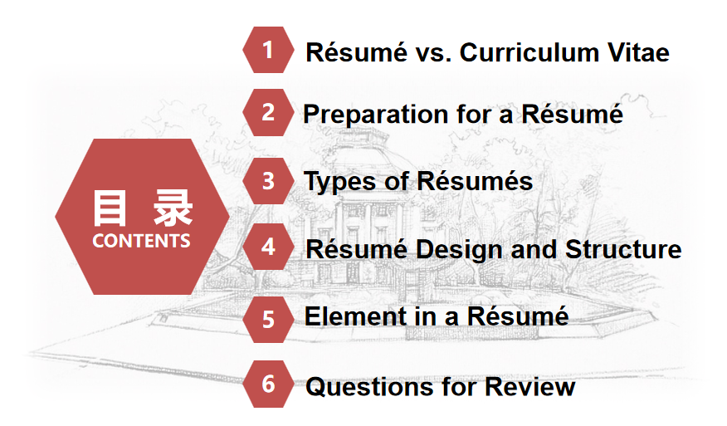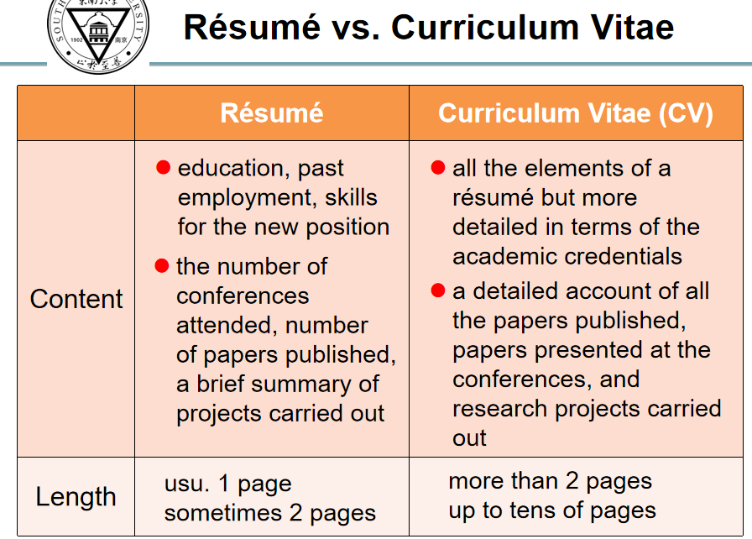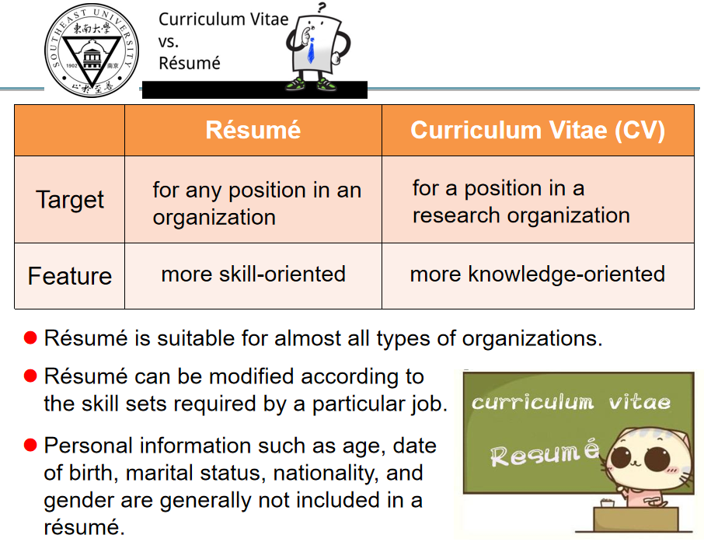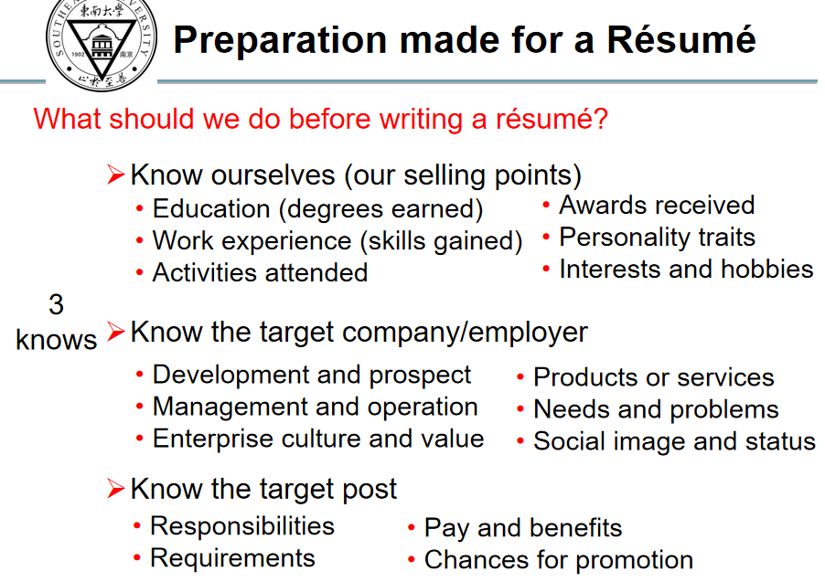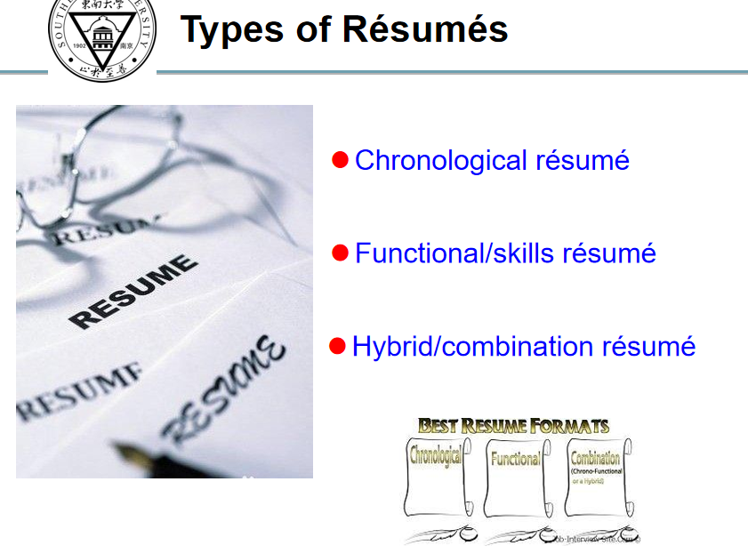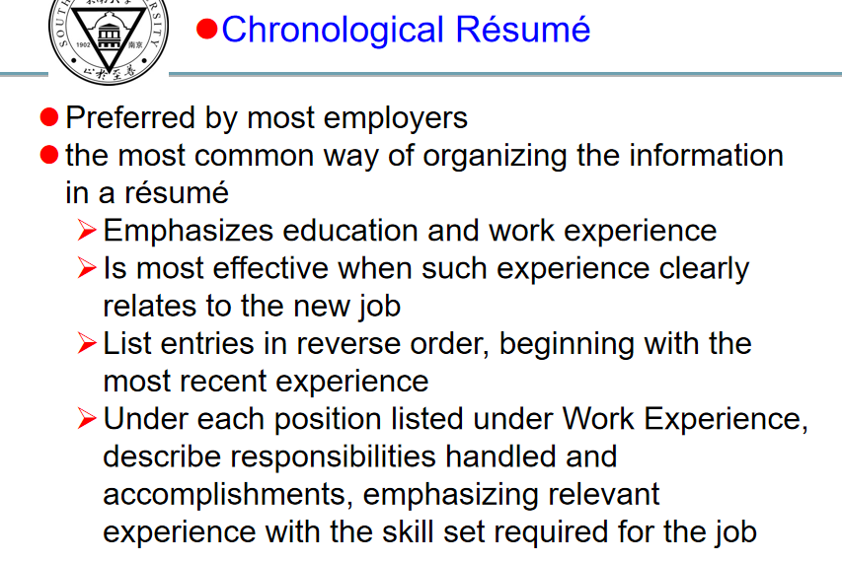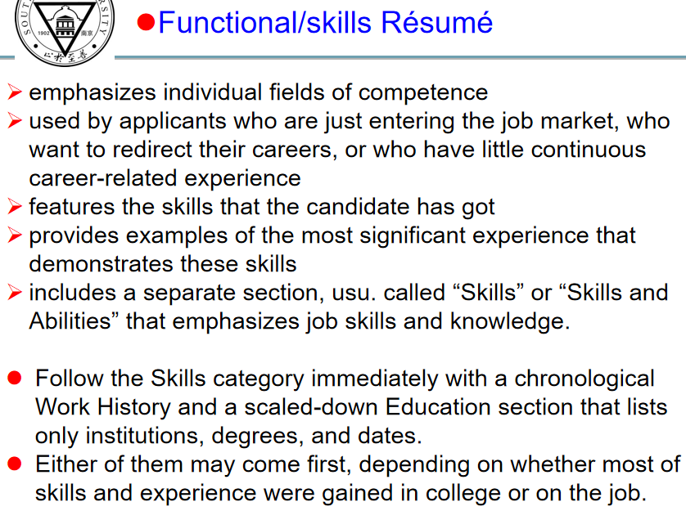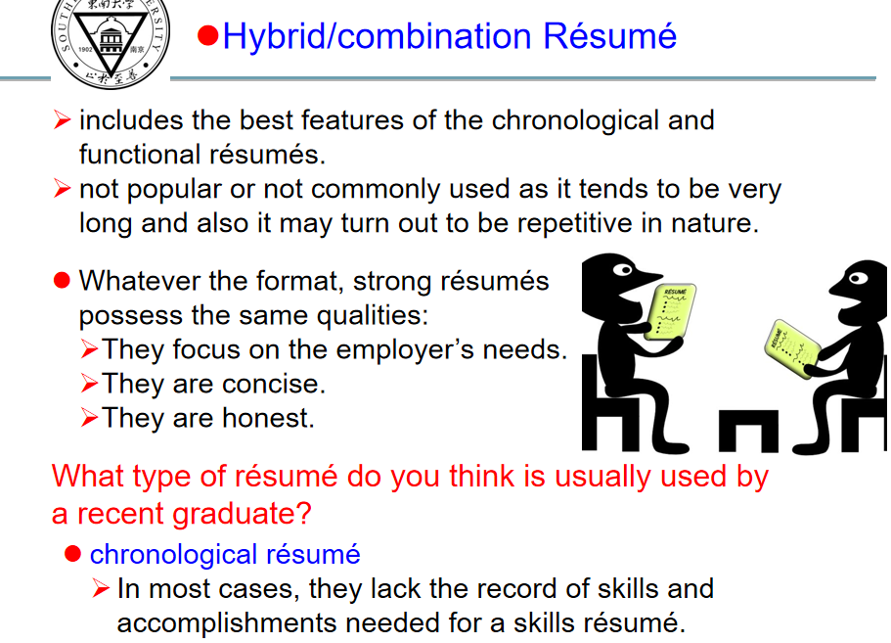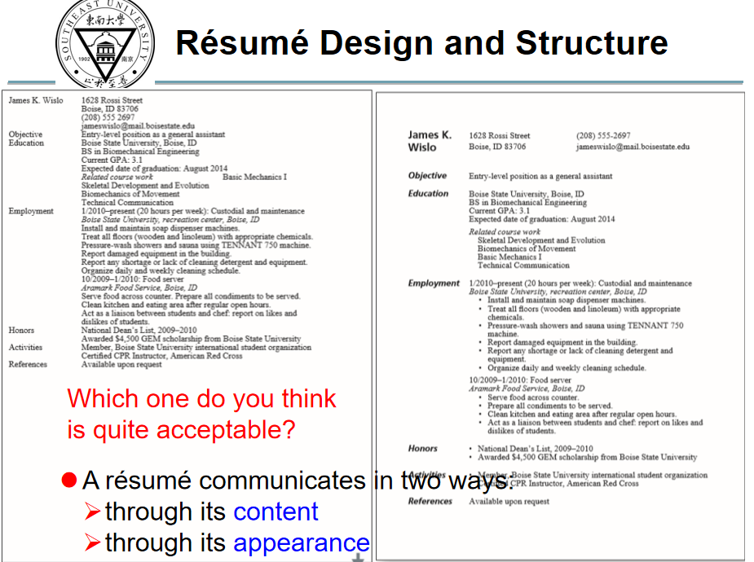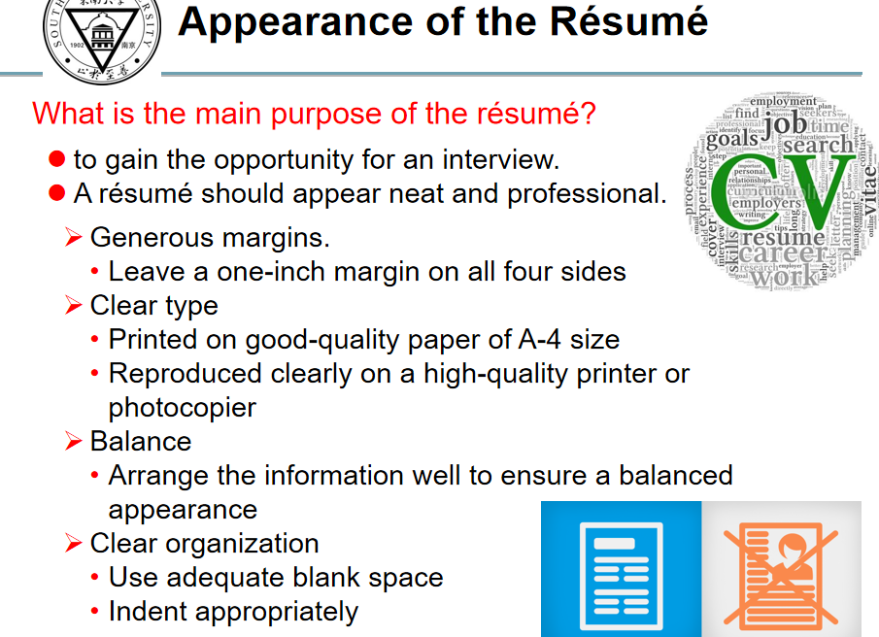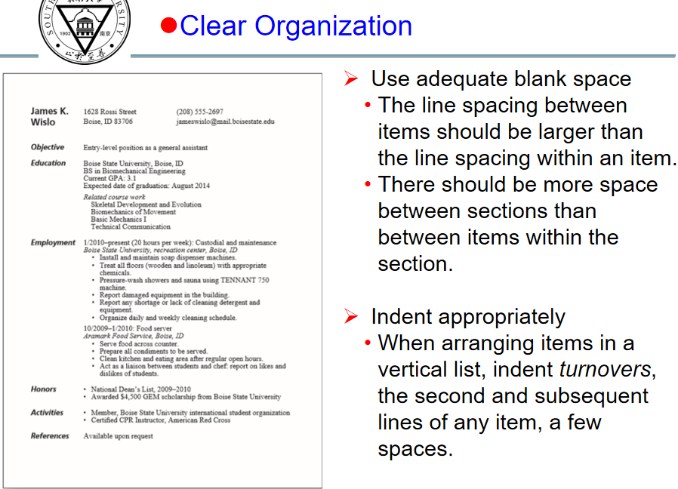

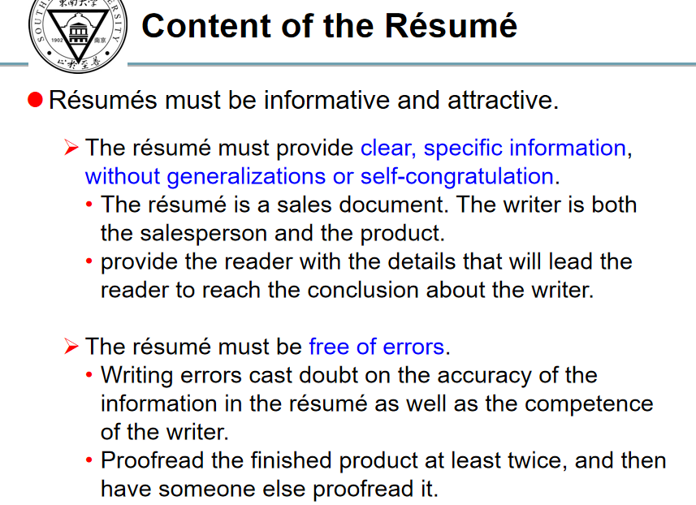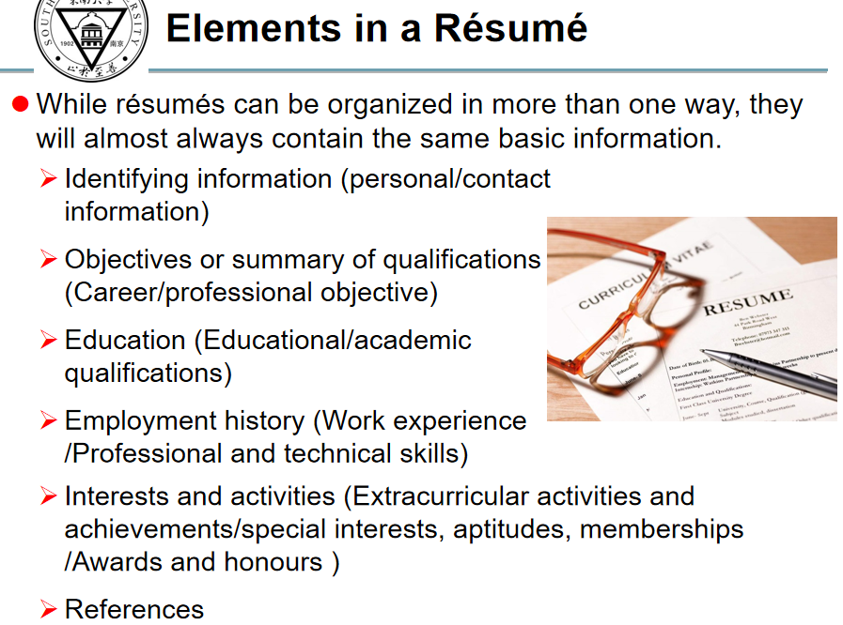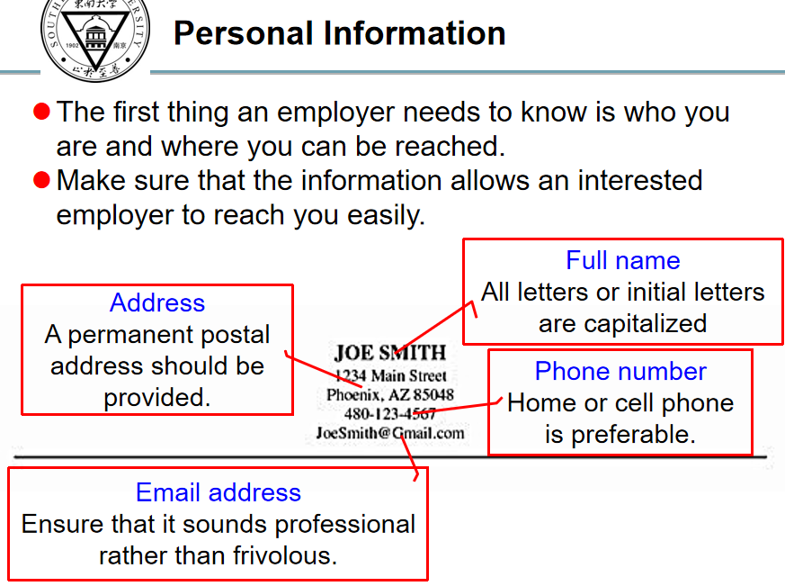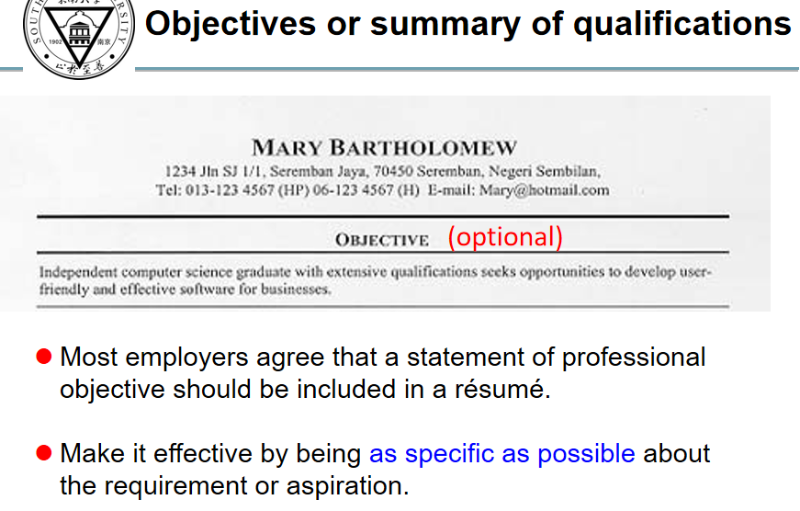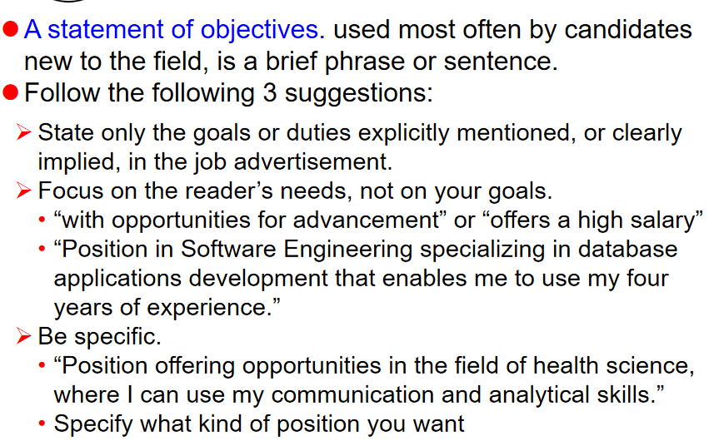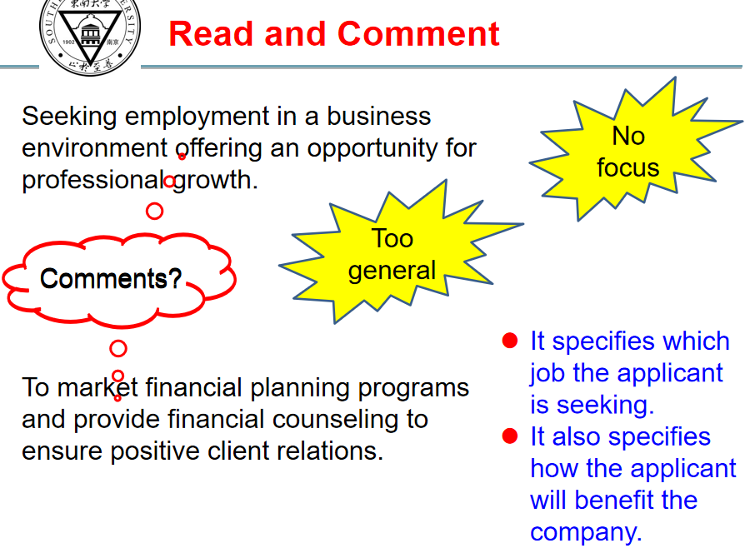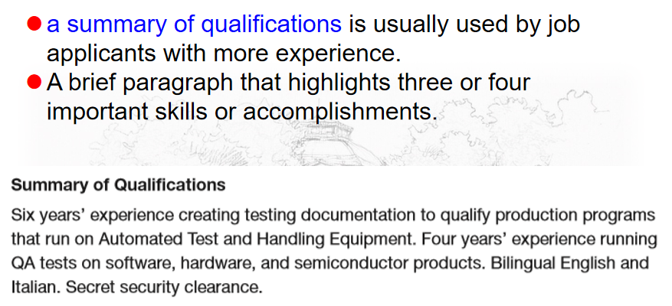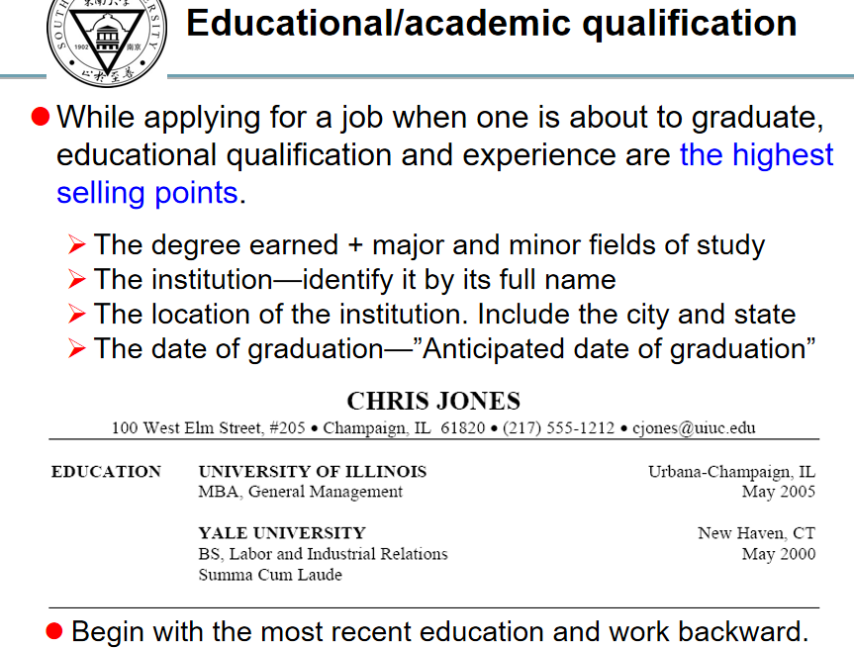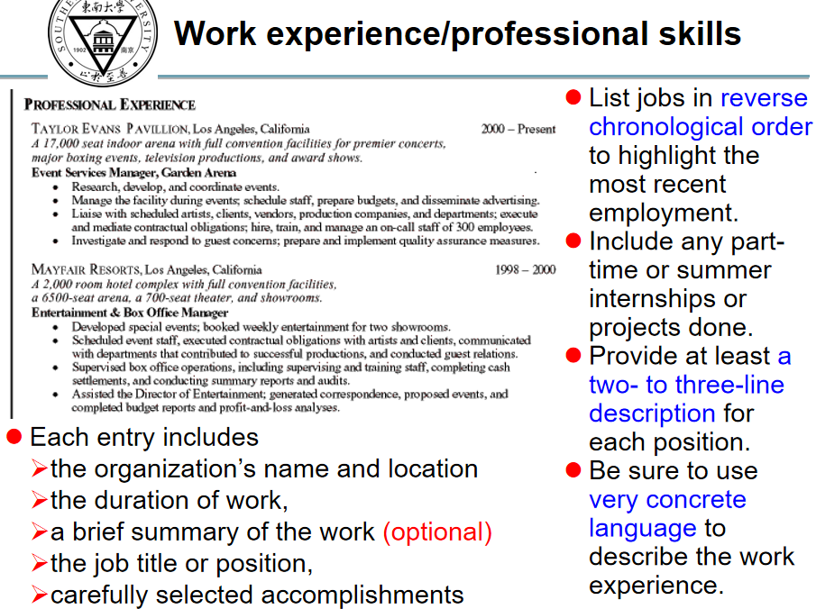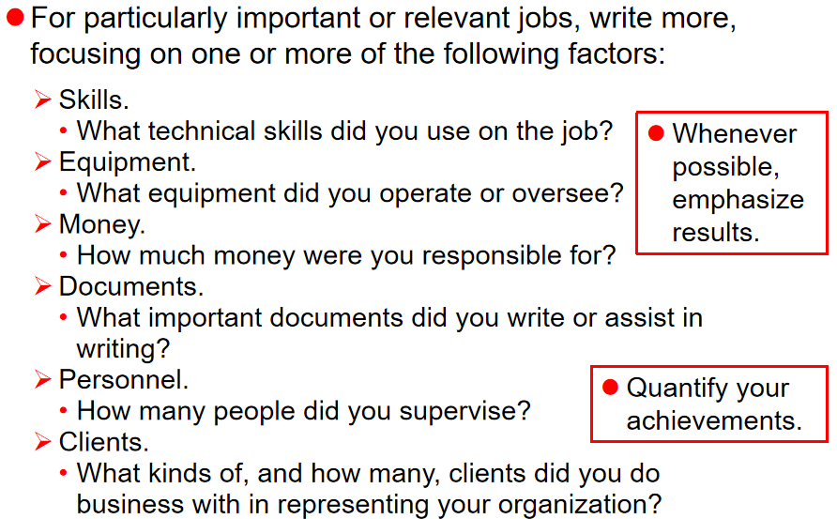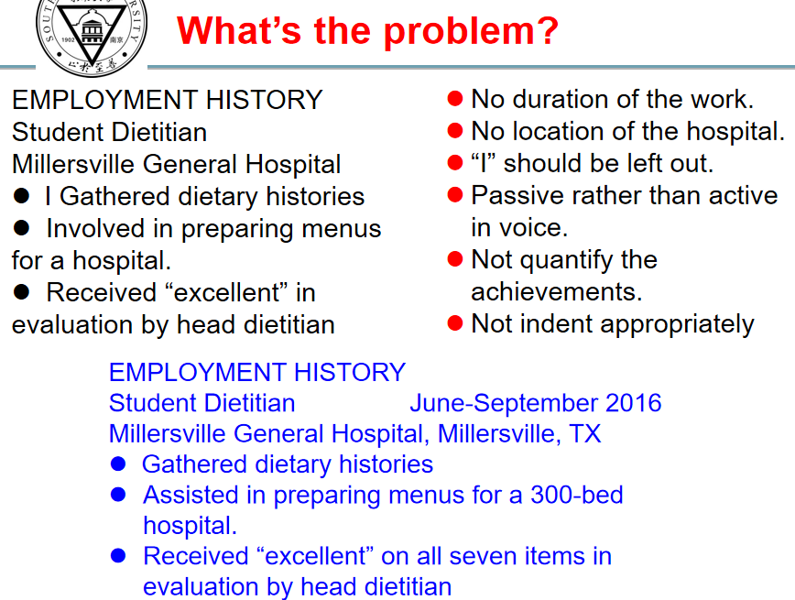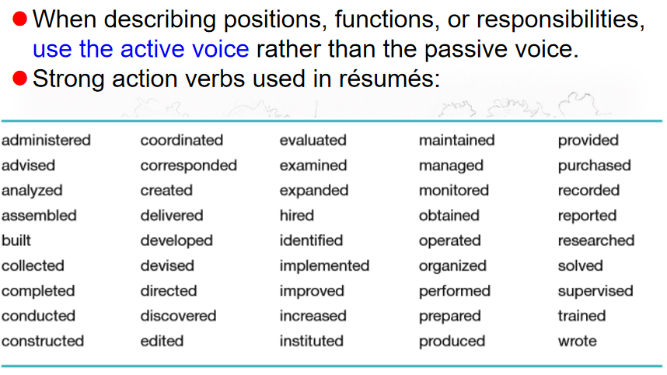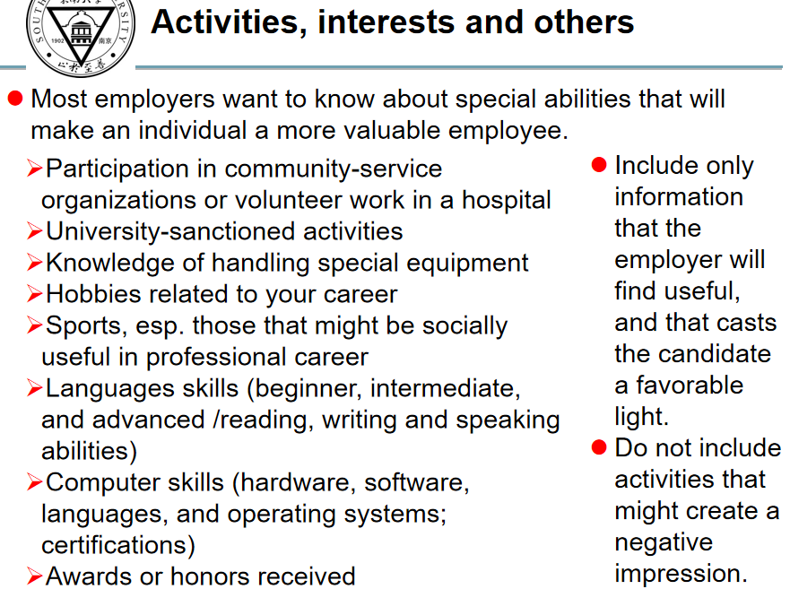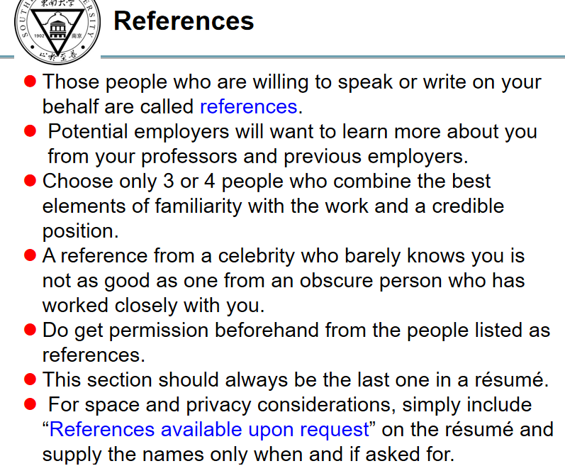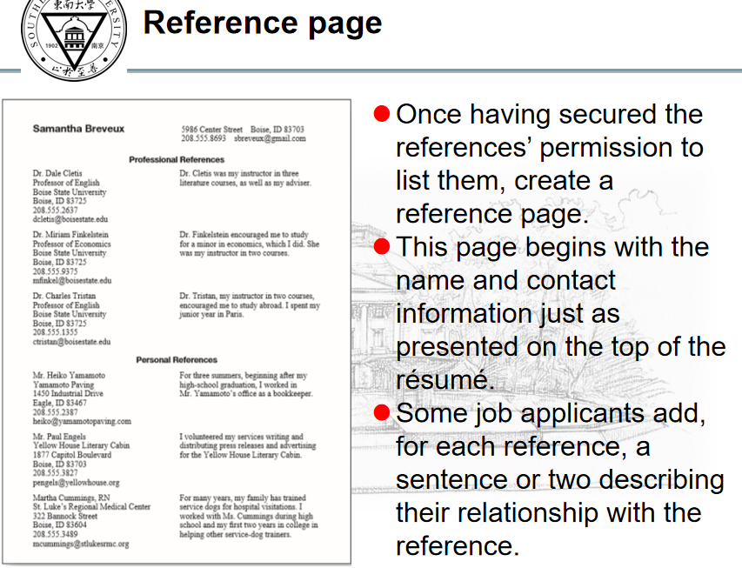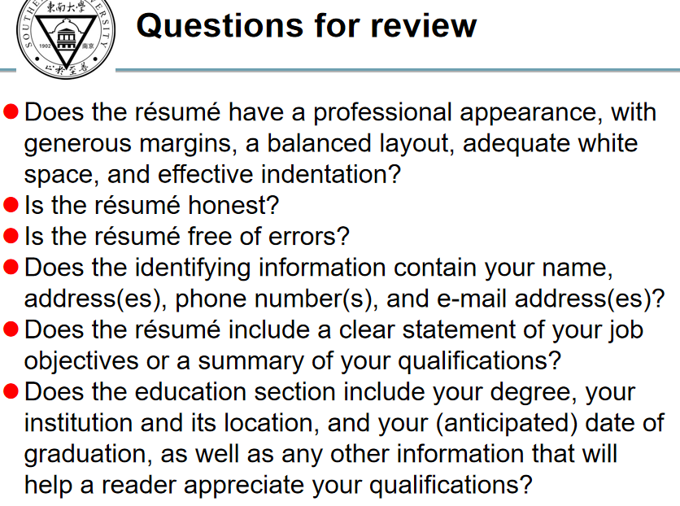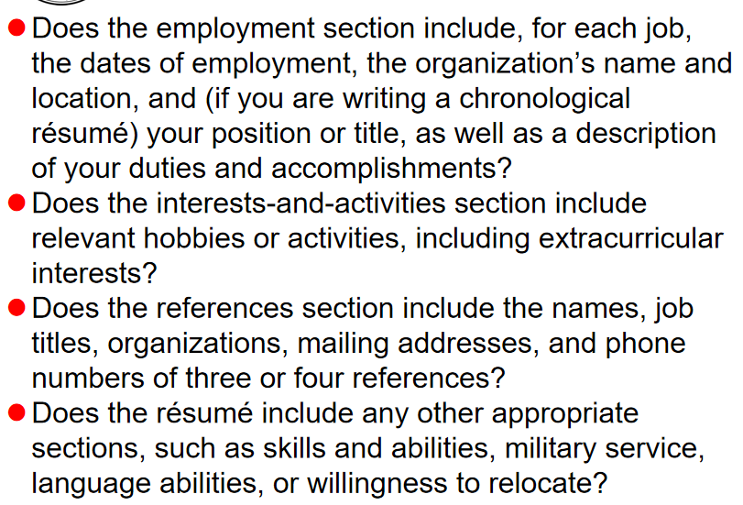

**Sample Cover letter**

John Donaldson

8 Sue Circle, Smithtown, CA 08067 · 909-555-5555 · john.donaldson@emailexample.com

August 14, 2020

George Gilhooley   
Times Union   
87 Delaware Road   
Hatfield, CA 08065

Dear Mr. Gilhooley,

I am writing to apply for the programmer position advertised in the Times Union. As requested, I enclose a completed job application, my certification, my resume, and three references.

The role is very appealing to me, and I believe that my strong technical experience and education make me a highly competitive candidate for this position. My key strengths that would support my success in this position include:

* I have successfully designed, developed, and supported live-use applications.
* I strive continually for excellence.
* I provide exceptional contributions to customer service for all customers.

With a BS degree in Computer Programming, I have a comprehensive understanding of the full lifecycle for software development projects. I also have experience in learning and applying new technologies as appropriate. Please see my resume for additional information on my experience.

I can be reached anytime via email at john.donaldson@emailexample.com or by cell phone, 909-555-5555.

Thank you for your time and consideration. I look forward to speaking with you about this employment opportunity.

Sincerely,

John Donaldson (signature hard copy letter)

John Donaldson